AWS KMS (Key Management Service)

AWS KMS (Key Management Service) is a fully managed encryption service
provided by Amazon Web Services that allows users to create, manage, and
control cryptographic keys used to secure data. It integrates with multiple AWS
services and helps protect sensitive information by enabling encryption,
decryption, and access control.
USE CASE :
A company stores customer financial documents in an S3 bucket. To ensure
sensitive customer data is protected, the organization uses AWS KMS to
encrypt files before storing them in S3. Only authorized IAM users and
applications are allowed to decrypt and access the files.
Create KMS Key
Click on create key --- Key Type: Symmetric ---- Key Usage: Encrypt and Decrypt ---
Alias --- Click Create Key
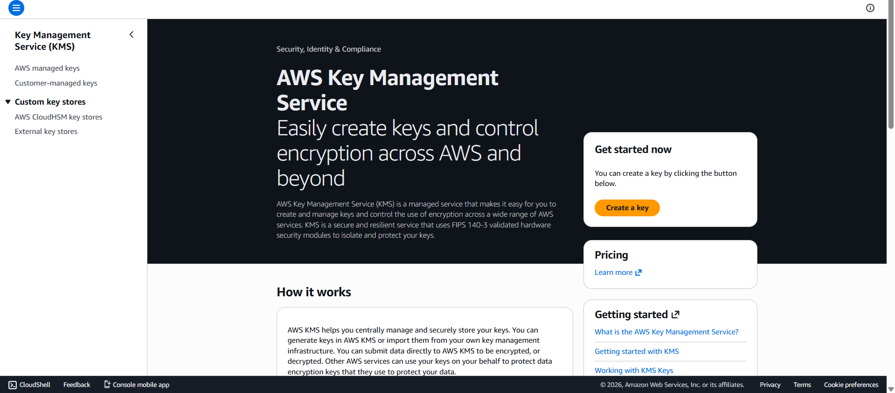
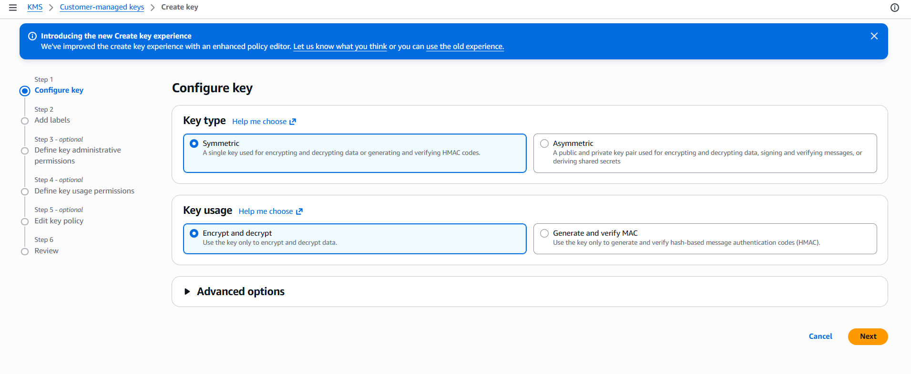
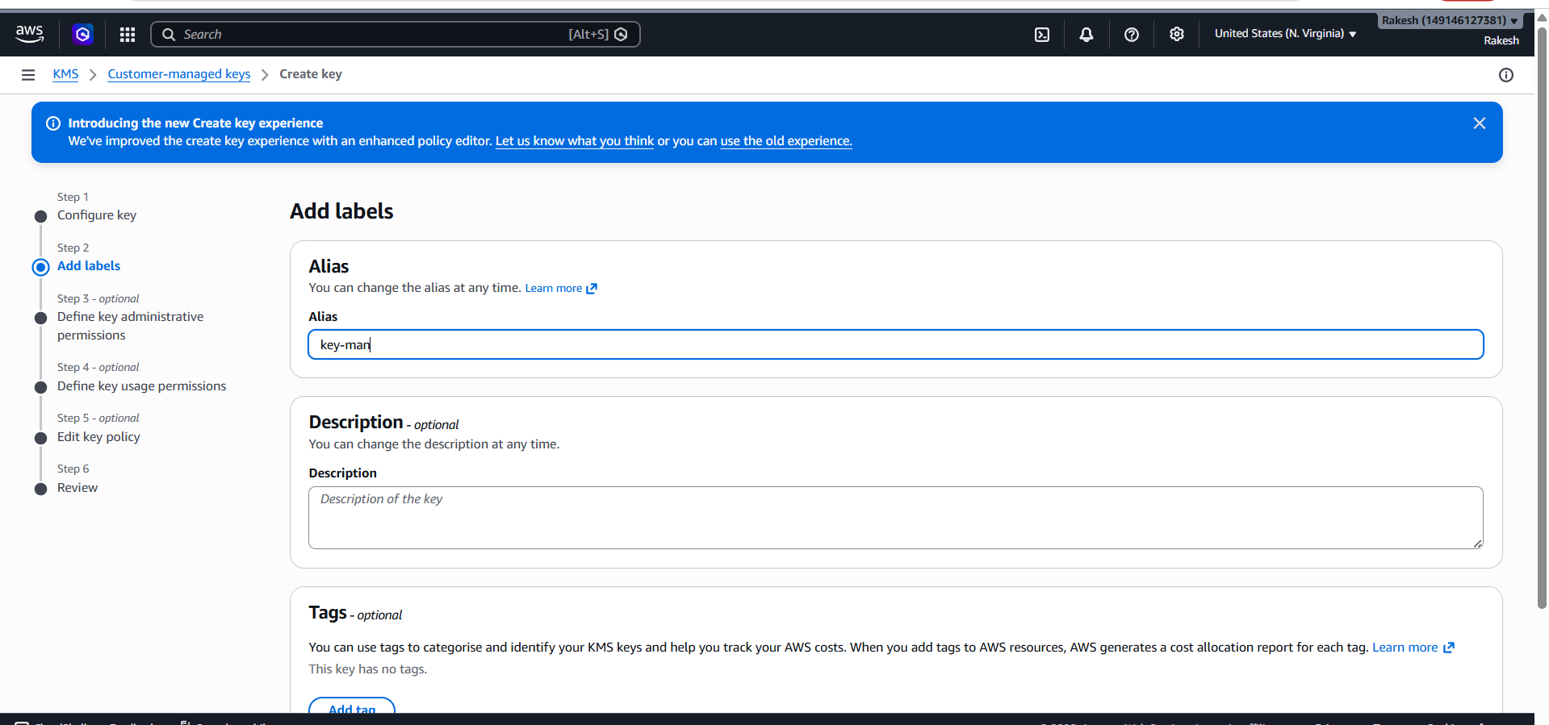
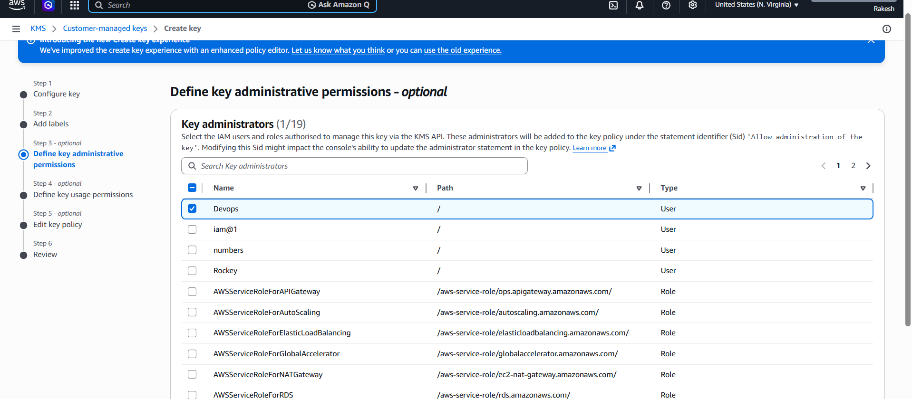
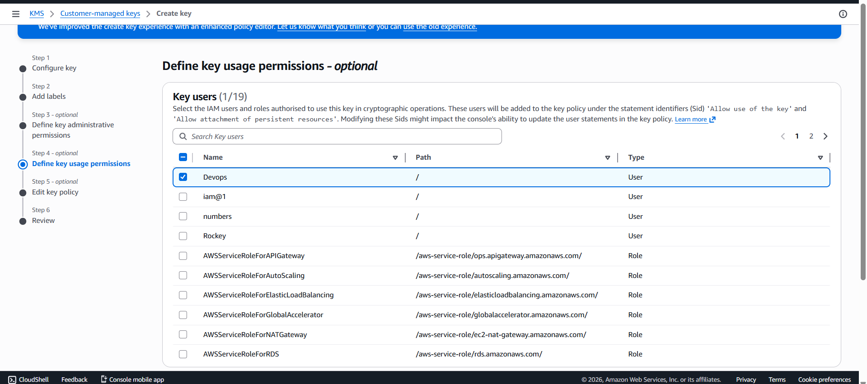
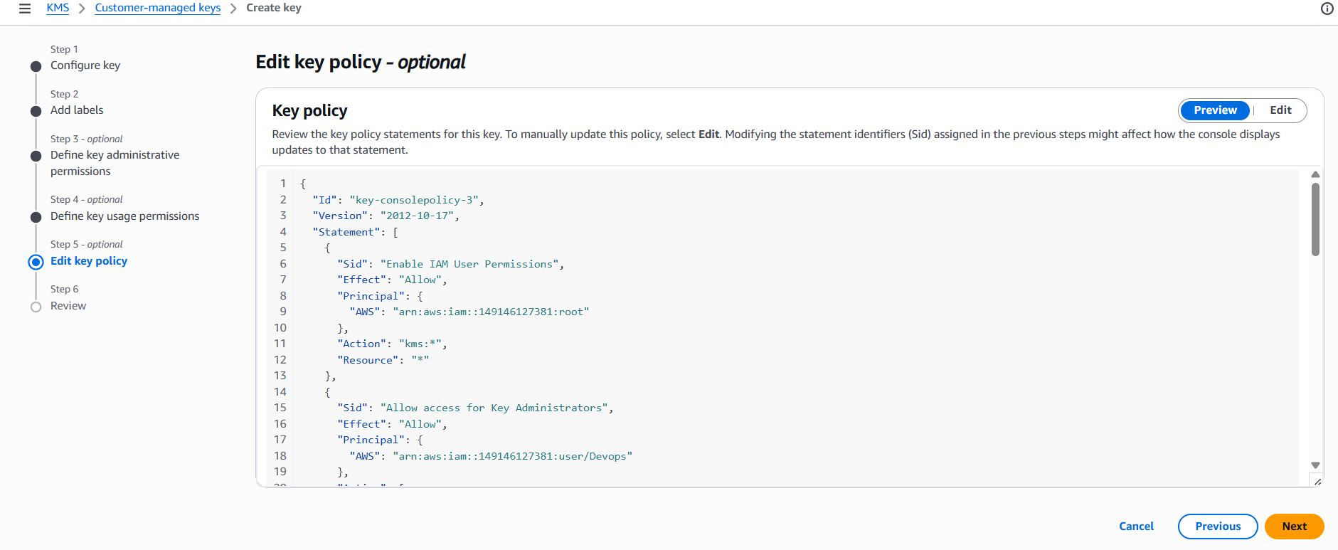
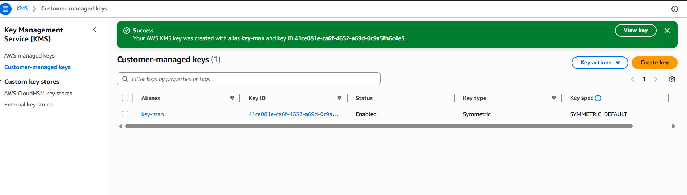
Create S3 bucket
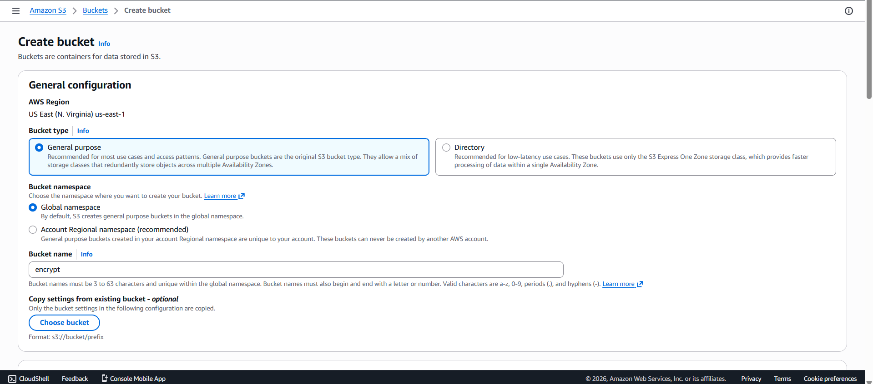
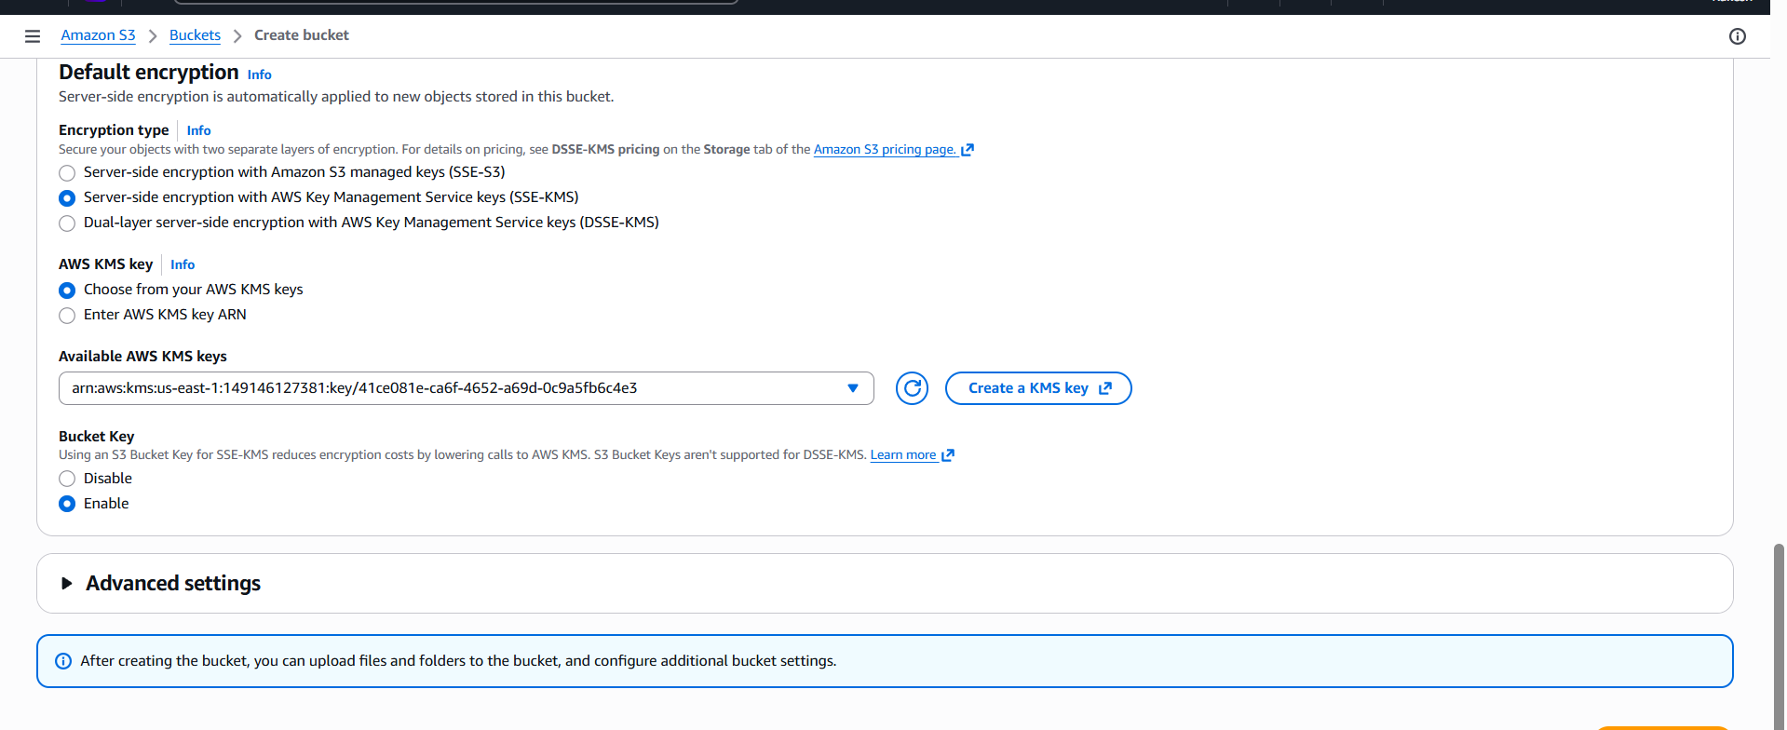

Enable KMS Encryption on S3 Bucket while create & add your key
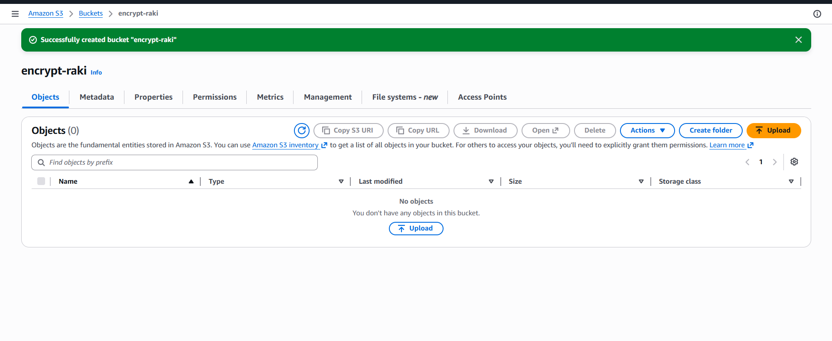
Upload a doc in s3 bucket
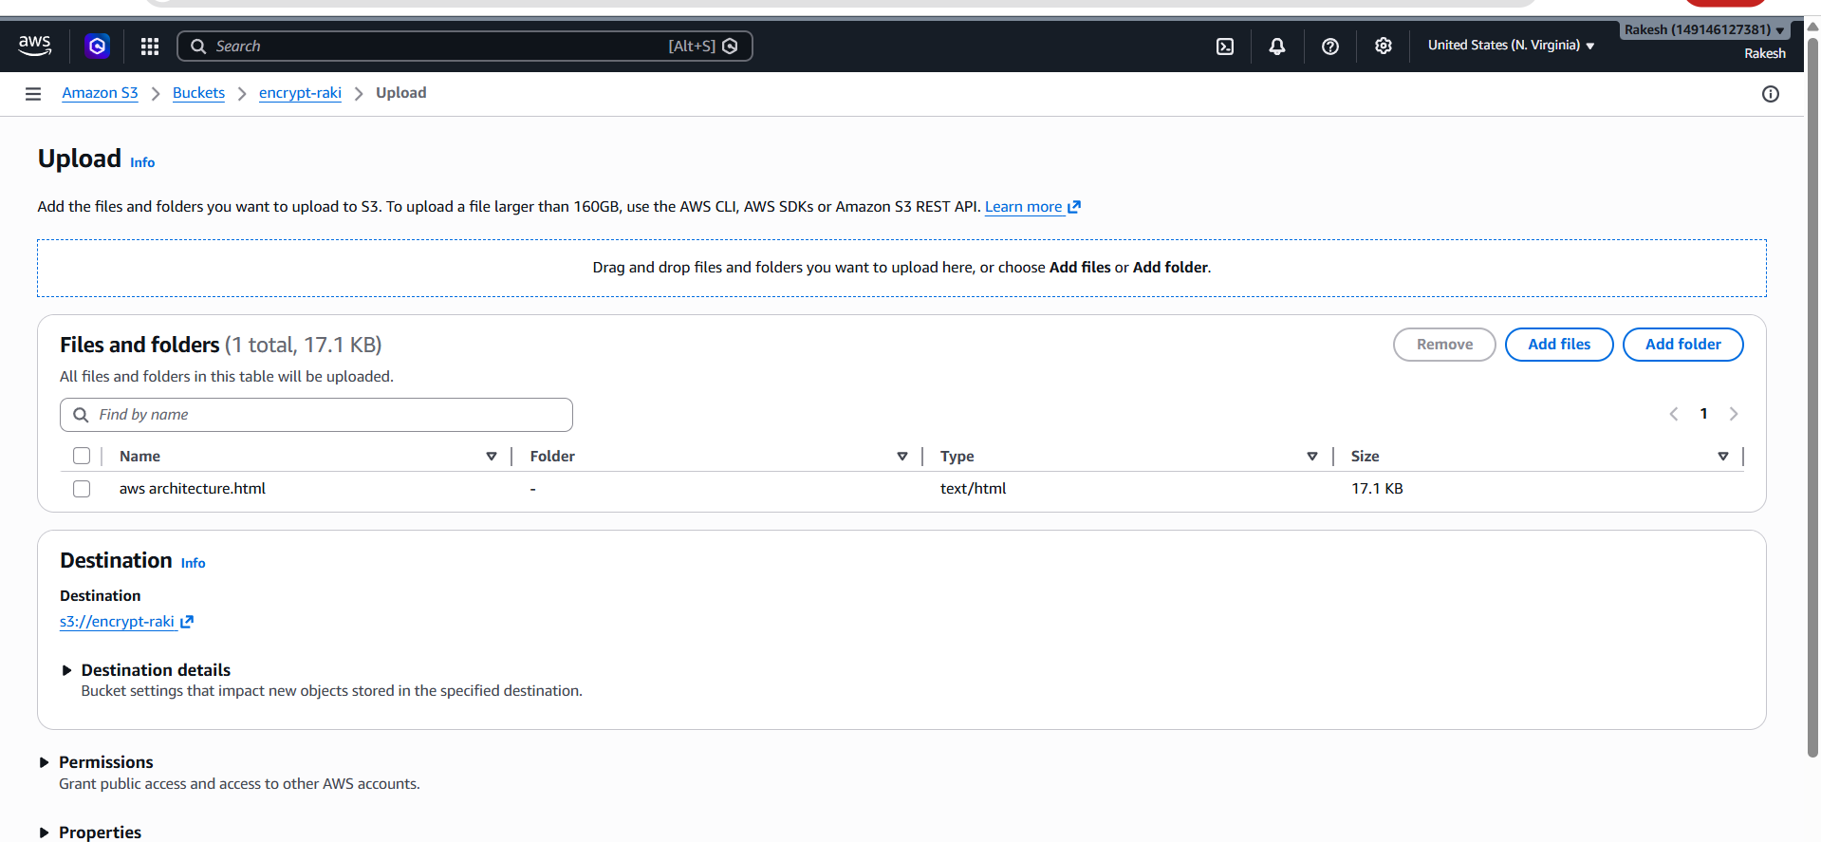

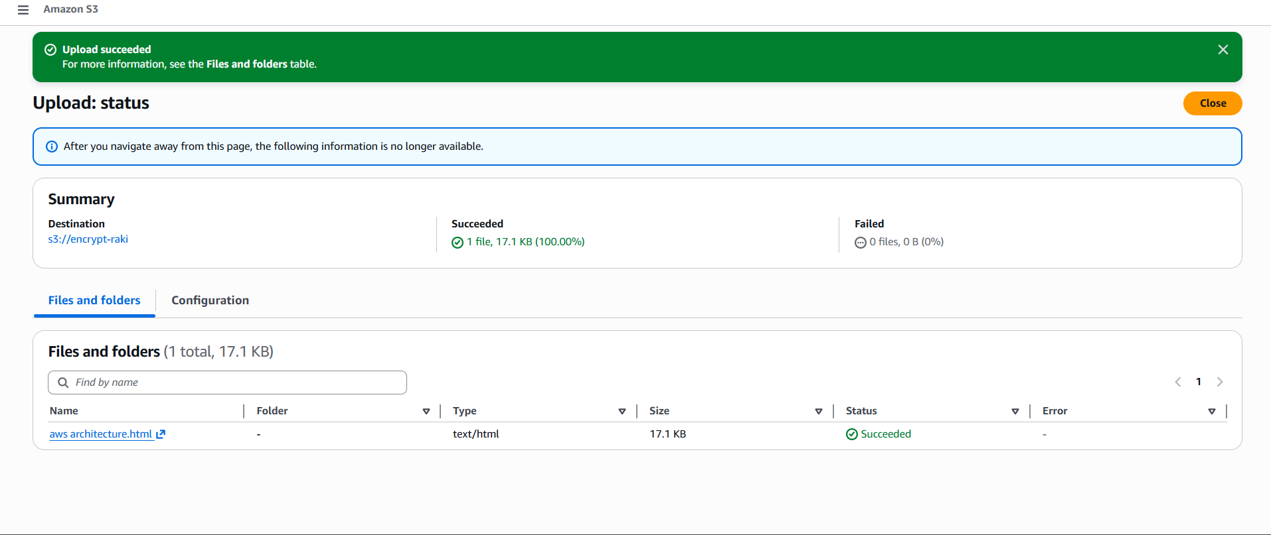
To verify
Go to s3 object --- properties ---we can see encryption key ARN
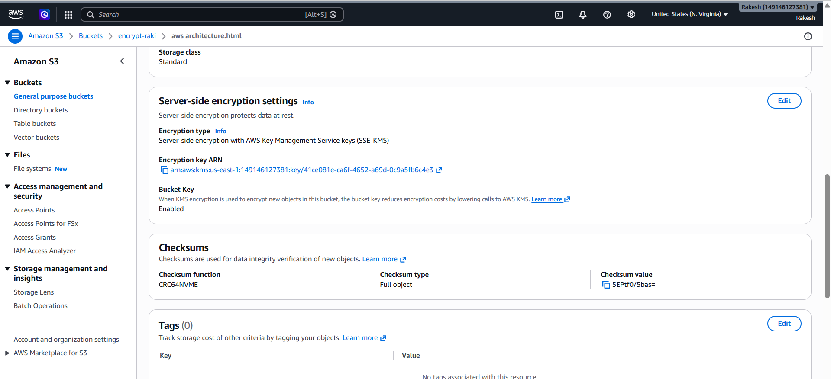
I have removed key access for the user and tried to download the object but
unable to download though the user has full s3 access
